Les « hexagrammes pénaux » (刑卦)

100-01-04. Hexagram Shihe 噬嗑
a. General composition (according to the Figure大象commentary, see 100-04)
Un hexagramme se lit toujours de bas (i.e. en venant de l’hexagramme précédent) en haut (allant vers l’hexagramme suivant)
- soit trait par trait
- soit en décomposant la Figure en deux trigrammes (le trigramme inférieur est dit interne 內, le supérieur est dit extérieur 外.
Un hexagramme est le retournement du précédent (sa « mutation »)

Lr
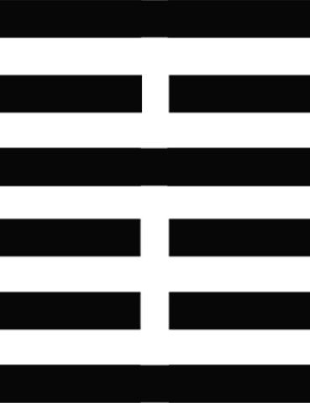

6. yang 上九
5. yin 六五 （不當位)
- yang 九四 (口中有物）

3. yin 六三
2. yin 六二
1. yang 初九

b. A superposition of two trigrams: “Action gives rises to Illumination”
☲ Li 離 Fire => “Enlightenment”

☳Zhen震 Thunder => “Awe”

100.-05 to 100-07: The four penal hexagrams, composed of the same three trigrams
Hex. 21. Shihe 噬嗑 Hex. 22: Bi 賁
☶Gen 艮 mountain (inertia)
“Arrest”
☲ Li 離 fire (dynamism)
“Enlightenment”

☲ Li 離 fire (dynamism)
“Enlightenment”
☳ Zhen 震 thunder (shake)
“Awe”

Hex. 55: Feng 豐 Hex. 56: Lü 旅

☲ Li 離 fire (dynamism)
“Enlightenment”
☶Gen 艮 mountain(inertia)
“Arrest”
“Arrest”

Gen

☳ Zhen 震 thunder (shake)
“Awe”
☲ Li 離 fire (dynamism)
“Enlightenment”

Li

100-08. Hexagram n° 61: Zhongfu中孚, “Inner sincerity”
a. “On the marsh there is wind: Inner confidence”

☴ Xun巽 Wind
Inner vacuum
☱ Dui兌 Marsh

b. Zhongfu as synthesis of the “four other penal hexagrams”

☶ Gen 艮 mountain (inertia) “Arrest
☳ Zhen 震 thunder (shake)
“Awe”

Zhongfu includes the Zhen and Gen trigrams that are components of the four penal hexagrams
It can also be read as a “doubled Li” ☲ (or “super-illumination”), whose each line has been doubled
Hence: all penal functions represented by the four other hexagrams find their resolution in the “inner truth”, or “inner confidence,” of the Judge, who “adjourns death penalty”.

Absent in Qiu Jun’s DXYYB, a sixth “penal hexagram” happens to be cited in other works:
Hexagram n° 40: Xie 解 composed of the the trigrams 坎 and 震.
震 zhèn) shake = (雷) thunder.

(坎 kǎn) gorge = (水) water

八卦 Bāguà—The eight trigrams
乾 Qián | 兌 Duì | 離 Lí | 震 Zhèn | 巽 Xùn | 坎 Kǎn | 艮 Gèn | 坤 Kūn
Heaven/Sky | Lake/Marsh | Fire | Thunder | Wind | Water | Mountain | Earth
天 Tiān | 澤(泽) Zé | 火 Huǒ | 雷 Léi | 風(风) Fēng | 水 Shuǐ | 山 Shān | 地 Dì

